|  |
| --- |
| Software Engineering Project |
| Electronic Health Record System |
| Requirements Report |
|  |
|  |
|  |

**05120000238 – Murat Can ÜSTE**

**05120000251 – Nagihan KALAYCI**

**05130000247 – Bilge ULUSAY**

**Contents**

1 Introduction 2

1.1 Purpose of the Requirements Document 2

1.2 Scope of the Product 2

1.3 Definitions, Acronyms and Abbreviations 2

1.3.1 Definitions 2

1.3.2 Acronyms 2

1.3.3 Abbreviations 2

1.4 References 2

2 Identification of Viewpoints 3

2.1 Principal Viewpoints of the System 3

2.1.1 Interactor Viewpoints 3

2.1.2 Indirect Viewpoints 4

2.1.3 Domain Viewpoints 4

2.2 Viewpoint Hierarchy Diagram 5

2.3 Requirements of each Viewpoint 5

2.3.1 Requirements of the Interactor Viewpoints 5

2.3.2 Requirements of the Indirect Viewpoints 6

2.3.3 Requirements of the Domain Viewpoints 6

3 Requirements Definition 7

3.1 Functional Requirements 7

3.2 Non-Functional Requirements 8

3.3 Domain Requirements 8

3.4 Volatile Requirements 8

3.5 Enduring Requirements 8

4 Requirements Interviews with Domain Experts 9

5 Requirements Prioritization and Negotiation 10

6 Requirements Traceability Matrix 11

7 Use Cases of Main Scenarios 12

8 Domain Model 13

# Introduction

## Purpose of the Requirements Document

This document contains the requirements of the *Electronic Health Record System.* It is written to allow people to understand *what* the EHRS should do.

In this document, we specify the viewpoints , stakeholders and the requirements of the *Electronic Health Record System* that will be implemented.

## Scope of the Product

The lately technological improvements in information technology (IT) have made a great impact on medical organizations. Today, health information systems are used in virtually every hospital. Health information technologies are used mainly to increase efficiency, quality of service and to reduce costs in hospitals.

*Electronic Health Record System* will provide the doctors and their staff with an electronic copy of the patient file. Personal information and medical information about the patient will be stored and managed by the system. Medical information may consist of any health related information related to a patient. Some important medical information the system supports can be listed as examinations, patient stories, symptoms, tests (blood, urine, etc.), diagnosis, treatments and prescribed medications. The system will also be able to assist physicians in diagnosing and treating a patient by providing diagnosis and treatment recommendations according to the provided information, remind patients of an upcoming event (any appointment, periodic check-up, periodic test, etc.) by sending emails or notifications and track information for billing purposes.

## Definitions, Acronyms and Abbreviations

### Definitions

* **Medical Science:** A broad term that covers such areas as biochemistry, molecular biology, medicinal chemistry, microbiology, neuroscience, physiology, nutrition, pharmacology, toxicology, vision science and biomedical technology.
* **Medical Record/Data:** The systematic documentations of a single patient’s medical history and care across time within one particular health care provider’s jurisdiction.
* **Drug Data:** Information on drugs and drug targets.

### Acronyms

* **EHRS:** Electronic Health Record System

### Abbreviations

## References

[1] Sommerville, Ian. 2010. *Software Engineering*. 9th ed. Pearson.

# Identification of Viewpoints

## Principal Viewpoints of the System

### Interactor Viewpoints

#### Users

|  |  |
| --- | --- |
| Viewpoint | Description |
| Doctor | Doctors who are responsible for assessing and treating patients. |
| Patient | Patients whose information is recorded in the system. |
| Nurse | Nurses who coordinate the consultations with doctors and administer some treatments. |
| Pharmacist | Pharmacists responsible for the dispensing of prescriptions, also the purchase, manufacture and quality testing of all medicines used in a hospital. |
| Laboratory | Hospital laboratories where tests are done on clinical specimens in order to obtain information about the health of a patient as pertaining to the diagnosis, treatment, and prevention of diesease. |
| Health Technician | Healthcare technicians who are responsible of assisting medical staff complete tasks around their assigned unit or clinic's and accommodate patient needs. |
| Hospital Kitchen | Hospital kitchen staff who provide meals to inpatients as per the instructions of the dieticians and physicians. |
| Registration and Admission | Medical receptionists who manage patients’ appointments and registration. |
| Accounting | Accounting Employees who are responsible for accumulating and reporting on financial information about the performance, financial position, and cash flows of the hospital |

#### System Staff

|  |  |
| --- | --- |
| Viewpoint | Description |
| System Administrator | System administrators who are responsible fort the upkeep, configuration, and reliable operation of the system. |
| IT Employee | IT staff who are responsible for installing and maintaining the system related hardware/software. |

### Indirect Viewpoints

|  |  |
| --- | --- |
| Viewpoint | Description |
| Hospital Management | Healthcare managers who obtain management information from the system. |
| Ministry of Health | Ensures that all organisations and institutions that produce health goods and services conform to standards of safety by setting policies, goals, regulations. |
| Ministry of Finance | Responsible for goverment finances, economic policy and financial regulations. |
| Insurance Company | Insurance companies which sell life insurance, annuities and pensions product. |
| Pharmaceutical Company | Pharmaceutical companies which discovers, develops, produces, and markets drugs or pharmaceuticals for use as medications. |

### Domain Viewpoints

|  |  |
| --- | --- |
| Viewpoint | Description |
| Hostpital Rules | Hospital rules and regulations affecting patient care and conduct. |
| Medical Science | Requirements and constraints related to medical science. |
| Medical Data | Requirements and constraints related to compiling and maintaning medical data. |
| Drug Data | Detailed drug data with comprehensive drug target information is needed for the system. |
| Insurance Policy | Domain requirements and constraints related to insurance policies. |

## Viewpoint Hierarchy Diagram

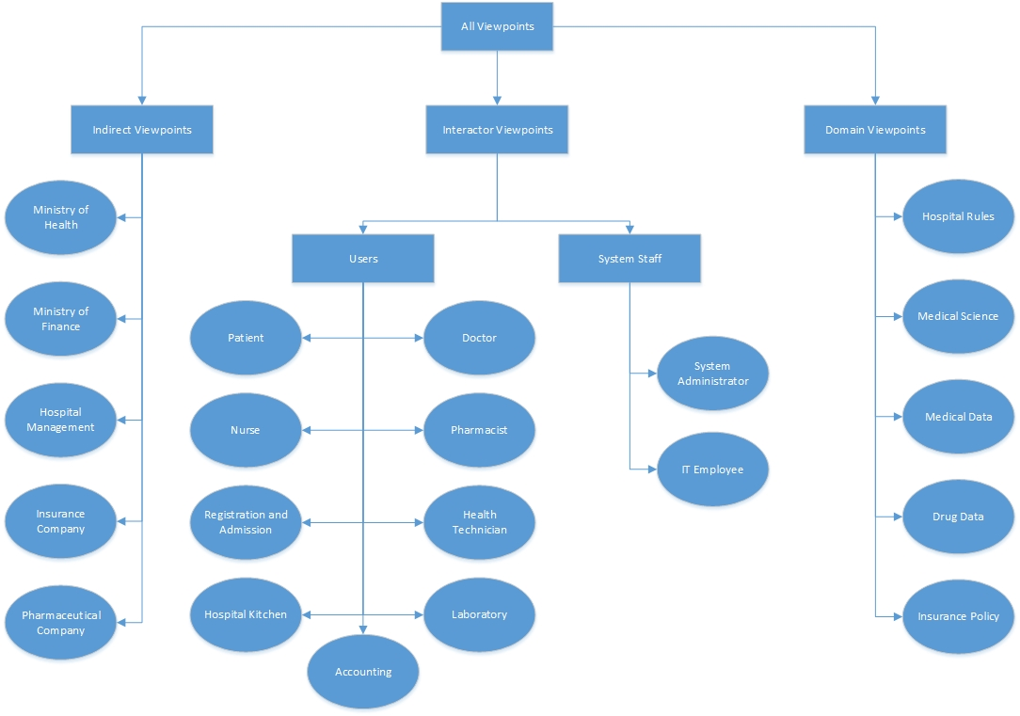

## Requirements of each Viewpoint

### Requirements of the Interactor Viewpoints

|  |  |
| --- | --- |
| Viewpoint | Requirements |
| Doctor | Manages patients’ medical informations, prescriptions, appointments and admissions entering the patients’ ID numbers. |
| Gets the recommendations about diagnosis and treatment from the system. |
| Patient | Books appointments entering the names of clinic,hospital and doctor. |
| Views his/her own medical informations, prescriptions, appointments,and admissions. |
| Gets notifications about upcoming events , such as appointments, check-ups, etc. |
| Nurse | Views and updates patients’ medical informations entering the patients’ ID numbers. |
| Views prescriptions of patients entering the patients’ ID numbers, and makes the vaccinations and gives the required medicines to the patients using the informations in the system. |
| Pharmacist | Views prescriptions of patients entering the patients’ ID numbers, and gives the required medicines to the patients using the informations in the system. |
| Manages the stocks of medicines entering the medical items’ ID numbers, check whether the stocks of medicines remain. |
| Laborant | Displays informations about the patients in the system entering the patients’ ID numbers ,and makes the necessary tests using the informations in the system. |
| Adds and updates laboratory results of patients entering the patients’ ID numbers . |
| Health Technician | Views and updates patients’ medical informations. |
| Hospital Kitchen Staff | Views patients medical informations of patients in. |
| Views patients’ admission informations in order to reach the number of in-patients. |
| Registration and Admission | Records the appointments by entering the informations of the patients, such as personal information, the name of doctor,clinic, the date and time into the system.  Manages admissions of patients. |
| Accounting | View patients information and the operations, treatments done on them for billing purposes. |
| Views hospitals stocks, purchase history, employee informations for keeping account of its finance. |
| System Administrator | Manages the system. |
| IT Employee | Installs required hardware/software to appropriate places in the hospital. |

### Requirements of the Indirect Viewpoints

|  |  |
| --- | --- |
| Viewpoint | Requirements |
| Hospital Management | Manages the hospital employees. |
| Determines rules and regulations related to the hospital. |
| Ministry of Health | Ensures that the hospital and the system conform the standarts of safety. |
| Ministry of Finance | Ensures that the hospital and the system abide by the goverment finances, economic policy and financial regulations. |
| Insurence Companies | Specifies different insurance policies for the patients that the system should know of. |
| Pharmaceutical Company | Publishes drug/medicine information that the system should know of. |
| Works with the hospitals for contracts about drugs/medicines that the hospital will use. |

### Requirements of the Domain Viewpoints

|  |  |
| --- | --- |
| Viewpoint | Requirements |
| Hospital Rules | Specific domain requirements related to hospital rules and regulations that the system should comply with. |
| Medical Science | Requirements and constraints related to the medical science that the system should comply with. |
| Medical Data | System should comply with the standarts of keeping medical data. |
| Drug Data | System should comply with the standarts of drug/medicine data. |
| Insurance Policy | System should be able to behave according to different policies when doing operations related to billing processes. |

# Requirements Definition

## Functional Requirements

|  |  |  |
| --- | --- | --- |
| Stakeholder | Id | Requirement |
| System |  | System shall generate profile of each person who is a citizen of that country. |
|  | System sends e-mail and message to patient to remind her/his appointment |
|  | System sends e-mail and message to patient every three months in order to remind her/his regular check-up |
|  | System sends e-mail and message to patient every months in order to remind her/his regular tests. |
|  | System shall send inpatients medical information and dieatry list to the hospital kitchen. |
|  | System shall alert to doctor about compliance with medaication of patient when he/she decides the treatment. |
|  | System shall give diagnosis and treatment recommendations to doctor. |
| Doctor (User) |  | Doctor shall to manage (view/add/update) patients medical information. |
|  | Doctor shall manage (view/add/update) patients prescriptions. |
|  | Doctor shall request patients admission and discharge to/from the hospital. |
| Patient (User) |  | Patient shall get an appointment from the system online. |
|  | Patient shall view his/her appointments from the system online |
|  | Patient shall view his/her prescriptions online. |
|  | Patient shall view his/her medical information online.(such as laboratory results) |
| Nurse (User) |  | Nurse shall view patients medical information. |
|  | Nurse shall update patients medical information. |
|  | Nurse shall view patients prescriptions. |
| Pharmacist (User) |  | Pharmacist shall get patient's medication information records page with patient identity number. |
|  | Pharmacist shall view patients prescriptions. |
|  | Pharmacist shall view hospitals drug/medicine stocks. |
| Laborant (User) |  | Laborants shall view patients information. |
|  | Laborants shall manage laboratory results of the patients. |
| Health Technician (User) |  | Health Technician shall view patients medical information. |
|  | Health Technician shall update patients medical information. |
| Hospital Kitchen Worker (User) |  | Hospital kitchen workers shall view patients medical information and dietary list. |
|  | Hospital kitchen workers shall view patients admission information. |
| Registration and Admission (Medical Receptionist – User) |  | Medical receptionist shall search the appointments list when patient call for making appointment |
|  | Medical receptionist shall manage patients appointments and admissions. |

|  |  |  |
| --- | --- | --- |
| Accounting |  | Accountant shall view the list of operations and treatments done on the patient as well as patients admission information. |
|  | Accountant shall view hospitals stocks and purchase history. |
|  | Accountant shall view employee informations. |
| System Administrator |  |  |
| IT Employee |  |  |

## Non-Functional Requirements

|  |  |  |
| --- | --- | --- |
| Category | Id | Requirement |
| Organizational Requirement |  | Users of system shall authenticate themselves using their identity number. |
|  | System shall designate identity number in ways that first three digit defining user's role. |
| Product Requirement |  | Flexible integration with a wide range of external entities |
|  | Interface shall implement device independent. |
| External Requirement |  | System shall be available to all users during daytime. Downtime shall not exceed 10 seconds in any one day. |
|  | System has to direct integration with diagnostic & other clinical equipment . |
|  | System has to e-prescribing with full interaction checks and alerts. |

## Domain Requirements

|  |  |
| --- | --- |
| Id | Requirement |
|  | Special drugs and prescription types that defined by Ministry of Health (Green Prescription, Red Prescription etc.) |
|  | Ministry of Health specifies prescription expire dates |
|  | Insurance discount must be considered while preparing the prescription total. |

## Volatile Requirements

|  |  |
| --- | --- |
| Id | Requirement |
|  | User permissions may change. (Must be editable by maintenance engineer.) |
|  | Prescription types may change (green, red etc.) |
|  | Changes of screen resolution |
|  | Hardware changes (for example: If server hard drive capability comes short) |

## Enduring Requirements

|  |  |
| --- | --- |
| Id | Requirement |
|  | Doctors add prescriptions |
|  | Pharmacists view and approve prescriptions |
|  | Stock listing ,stock decrementing |

# Requirements Interviews with Domain Experts

In this part, we list the requirements taken from domain experts during an interview with them.

|  |  |  |
| --- | --- | --- |
| Name : | |  |
| Job : | |  |
| Telephone : | |  |
| Email : | |  |
| Id | **Requirement** | |
|  | System shall send informative e-mail for pregnant woman for her and baby health. | |
|  | System shall alert to mother for vaccine time of her baby. | |
|  | System shall alert to cancerous patient who has to come for check-up every year,every two year and every five year. | |
|  | System shall alert to each woman for breast cancer tests every six months. | |

|  |  |  |
| --- | --- | --- |
| Name : | | Nurşen ÜSTE |
| Job : | | Nurse |
| Telephone : | | +90 507 205 55 81 |
| Email : | | - |
| Id | **Requirement** | |
|  |  | |
|  |  | |
|  |  | |
|  |  | |

# Requirements Prioritization and Negotiation

# Requirements Traceability Matrix

# Use Cases of Main Scenarios

|  |  |  |
| --- | --- | --- |
| Id : | UC1 | |
| Title : | **Treatment Recommendation** | |
| Description : | **System shall give diagnosis and treatment recommendations to doctor.** | |
| Primary Actor : | | *System* |
| Stakeholders and Interests : | | * ***Patient*** * ***Doctor*** |
| Preconditions : | | * Doctor shall sign in the system with his/her ID number. * Informations of patient, such as recent tests and health records must be recorded to the system. |
| Success Guarantee (Postconditions) : | | * System recommend the treatment in accordance with patient’s analysis. |
| Main Success Scenario : | | 1. Doctor views patient’s profile by searching with his/her ID number. 2. Doctor records the diagnosis of patient to the system. 3. System lists treatments about that diagnosis . 4. Doctor chooses from recommendation or record new treatment. 5. System records the choosen/recorded treatment to patient’s profile. |
| Alternative Flows : | | *1a. System fails while searching for the patient’s profile.*   1. Doctor sends a request to the system for reopening the profile*.*   *2a. Patient’s tests are clear for any diagnosises.*   1. Doctor sends a request in order for new tests to be done. |
| Exceptions: | | System is not allowed to add a new treatment. |

|  |  |  |
| --- | --- | --- |
| Id : | UC2 | |
| Title : | **Appoinment Reminder** | |
| Description : | System sends e-mail and message to the patient in order to remind her/his appointment. | |
| Primary Actor : | | *System* |
| Stakeholders and Interests : | | * ***Patient*** |
| Preconditions : | | * Patient must have an appointment. * The appointment must be recorded at the system. |
| Success Guarantee (Postconditions) : | | * System sends reminder to patient according to patient’s choice (e-mail&message) . |
| Main Success Scenario : | | 1. System checks the appointment list every day.  2. System determines patients’ appointments before 3 days.  3. System decides about sending e-mail or sending message according to patient choice.  4. System sends e-mail/message each day till the appointment day. |
| Alternative Flows : | | *1a. Patient does not choose the way of reminder.*  1. System sends e-mail and message for reminding. |
| Exceptions : | | The system reminder crushes. |

|  |  |  |
| --- | --- | --- |
| Id : | UC3 | |
| Title : | **Calculation of the examination fee of the patient.** | |
| Description : | Systemt shall generate the examination fee of the patient. | |
| Primary Actor : | | *System* |
| Stakeholders and Interests : | | * The patient must have been examined. * Examination information must be entered |
| Preconditions : | | * Patient must be treated. * Treatment records must be entered**.** |
| Success Guarantee (Postconditions) : | | * The system generates the patient's examination expense. |
| Main Success Scenario : | | 1. The system lists prices of the examinations made to the patient 2. The system checks the patient's insurance policy. 3. According to the patient's insurance policy, the system implements the necessary discounts. 4. The system charges the patient's total examination fee. |
| Alternative Flows : | | *2a. The system cannot find any registered health insurance for the patient*   1. The system does not not apply any discount to the examination fee to be paid. |
| Exceptions : | | The System crushes. |

|  |  |  |
| --- | --- | --- |
| Id : | UC4 | |
| Title : | **Managing Patients Medical Informations** | |
| Description : | Doctor shall manage (view/add/update) medical informations of patients. | |
| Primary Actor : | | *Doctor* |
| Stakeholders and Interests : | | * ***Patient*** * ***System*** |
| Preconditions : | | * Doctor shall enter the system with his/her ID number. * Doctor must have access permission to display profiles of patients. * Informations of patient’s health records must be recorded the system. |
| Success Guarantee (Postconditions) : | | * Doctor views / adds / updates patient’s medical informations. |
| Main Success Scenario : | | 1. Doctor enters a patient’s ID number to the system.  2. System shows the patient’s profile.  3. Doctor records the patient’s complaints ,test results and diagnosis to the system.  3. Doctor records or changes the treatment. |
| Alternative Flows : | | *...* |
| Exceptions : | | The System crushes. |

|  |  |  |
| --- | --- | --- |
| Id : | UC5 | |
| Title : | **Regular Check-Up Reminder** | |
| Description : | System sends an email and a message to the patient every three months in order to remind her/his regular check-up. | |
| Primary Actor : | | *System* |
| Stakeholders and Interests : | | * ***Patient*** |
| Preconditions : | | * Patient must be registered on the system. |
| Success Guarantee (Postconditions) : | | * System sends reminder to patient according to patient’s choice (e-mail&message) . |
| Main Success Scenario : | | 1. System checks the check-up list every day.  2. System determines patients’ check-up dates before 3 days.  3. System sets the next check-up date as 3 months later.  4. System updates new check-up date to the check-up list.  5. According to the preference of the patient, the System sends an email or a message each day till the check-up day. |
| Alternative Flows : | | *1a. Patient does not choose the way of reminder.*  1. System sends e-mail and message for reminding. |
| Exceptions : | | The System reminder crushes. |

# Domain Model